

Ashdon Primary School
2026 Autumn Menu - Week 1

W/C – 31st Aug / 14th Sep / 28th Sep / 12th Oct / 2nd Nov / 16th Nov / 30th Nov / 14th Dec
 | Monday | Tuesday | Wednesday | Thursday | Friday
Main Meal | Tomato & Cheese Pizza | Jacket Potato  with homemade (mild) chilli – con - carne | Roast Chicken | Homemade Pork Sausage Rolls | Crispy Fish Fingers
Vegetarian  option | Cheddar Cheese Panini | Jacket Potato with Cheese | Quorn Fillet | Cheese & Pesto Parcels | Vegetarian Fingers
On the side | Salad Bar | Salad Bar | Roast Potatoes, seasonal veg, tidgy puds & gravy | Mashed Potatoes & Baked Beans | Chips & Peas
Dessert | Fresh Fruit | Fruit Jelly | Flapjacks | Peaches & Cream | Ice Cream Pots

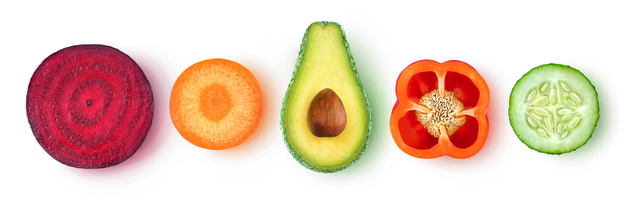
Fresh fruit and yogurts available daily

