
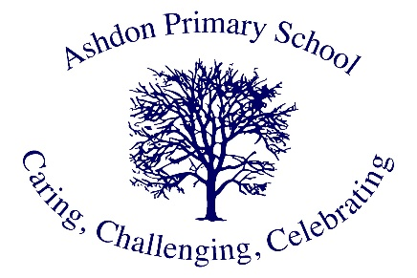
Ashdon Primary School
Science Policy

Introduction
Science is a core subject within the National Curriculum. This policy outlines our school's aims, principles, and strategies for the delivery of Science at Ashdon Primary School.

Our Vision and Aims
At Ashdon Primary School, our children are scientists! It is our intention to provide a high-quality Science education that will equip our children with the foundations they need to understand the significance of Science in their daily lives and develop a deeper appreciation of the world around them. Through our carefully crafted curriculum, our children will cultivate a genuine passion for scientific discovery.
We are committed to offering our children diverse opportunities to fully immerse themselves in their learning journey. We want our pupils to carry lasting memories of their Science lessons at Ashdon, creating experiences they will treasure in years to come. Our vision is to nurture ambitious individuals who dare to dream big and recognise no boundaries when envisioning their future careers, whether as astronauts, forensic scientists, or microbiologists.
To realise this vision, we ensure our teaching incorporates exciting, hands-on practical experiences that spark curiosity and encourage questioning. These engaging and challenging learning opportunities help every child solidify and expand their scientific knowledge and vocabulary whilst fostering an enduring enthusiasm for learning.

Teaching and Learning
At Ashdon Primary School, Science is taught throughout all year groups from the early years to year six, following the Hamilton Trust Science schemes of work to ensure comprehensive coverage of the National Curriculum through an enriching approach that captures our pupils' imagination.
Each pupil maintains a Science book where they showcase their work and achievements across the academic year. We ensure that learning builds progressively upon previous knowledge, developing depth of understanding and advancement of skills throughout the pupils' journey.
Our teachers foster enthusiasm and engagement across the scientific disciplines: Biology, Chemistry and Physics. Pupils are encouraged to explore, question, predict, plan, conduct investigations and observations, and draw meaningful conclusions. They present their findings and learning using scientific language, detailed observations and precise diagrams.

Curriculum Delivery Strategies
- Regular revision of previous learning to support pupils in their ability to 'know more and remember more'
- Implementation of Practise and Greater Depth opportunities
- Continuous professional development for staff
- Educational visits and expert visitors
- Effective assessment strategies to identify and address misconceptions
- Skilful teacher modelling
- Appropriate scaffolding and differentiation
- Clear success criteria
- Regular self and peer assessment
- Meaningful cross-curricular links with Mathematics, English and Computing

Assessment and Achievement
Pupil progress is assessed against taught objectives each term, with achievements recorded as working above, at or below expected levels.

Expected Outcomes
The effectiveness of our Science curriculum at Ashdon Primary School is evident in our pupils' strong progress over time, across key stages, relative to their individual starting points and progression of skills. Through this carefully structured approach, pupils leave Ashdon reaching at least age-related expectations for Science.
Through our enrichment programme of workshops, educational visits and interactions with experts, our Science curriculum cultivates enthusiastic learners who recognise how Science has transformed our lives and understand its crucial role in our world's future prosperity. We empower our pupils to recognise their potential as future innovators and change-makers in the scientific community.
The success of our approach is demonstrated through multiple channels, including pupil voice, the high quality of work produced, and most notably, our pupils' genuine enthusiasm and love for Science. This positive impact is reflected in their confident approach to scientific enquiry and their ability to apply scientific concepts to the world around them.

Monitoring and Review
This policy will be reviewed annually by the Science Subject Leader and Senior Leadership Team.
Last reviewed: January 2025
Next review date: January 2026

