
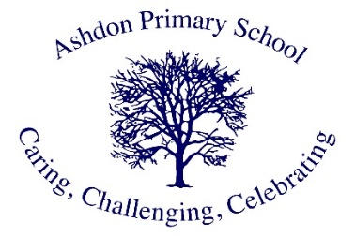

Ashdon Primary School
Philosophy 4 Children Vision

Vision Statement

At Ashdon Primary School, Philosophy for Children (P4C) provides pupils with a unique space to develop their speaking, listening, and thinking skills. Through our philosophy assemblies, we teach oracy—the ability to communicate effectively using spoken language. This vision is implemented through a dedicated weekly whole school assembly where our entire school community comes together to engage in philosophical discourse.

Core Communication Skills

Through P4C, we develop students' abilities to:

Express themselves effectively and confidently

Speak eloquently and articulate ideas clearly

Influence through verbal communication while listening and responding to others

Develop and utilize appropriate vocabulary

Structure thoughts coherently for others' understanding

Philosophy and Curriculum Integration

Approaching the National Curriculum philosophically means exploring beyond surface-level facts to examine questions and concepts that engage pupils and teachers alike. Philosophy harnesses imagination and reasoning to explore fundamental concepts such as justice, truth, knowledge, and beauty. Within our philosophical community of enquiry, adults and pupils collectively search for meaning. Students become reasonable in dual aspects—developing strong reasoning abilities while remaining receptive to others' perspectives.

As Socrates (470-399 BCE) stated, "The unexamined life is not worth living."

Implementation Strategy

Assembly Structure

Classes develop and select their own philosophically rich questions aligned with termly topics

Discussions emphasize full, considered sentences and respectful listening

Student-driven subject matter enables speakers to be authorities on their chosen topics

Peer and teacher attention builds student confidence

Extended discussions enhance articulation and critical thinking skills

Benefits for All Learners

SEND and disadvantaged pupils particularly benefit from opportunities for extended discourse

Students experience reasoned debate and cordial disagreement

Sessions begin with thought-provoking stimuli connected to curriculum or relevant issues

Group readings of books and stories serve as discussion catalysts

Vocabulary expansion through concept exploration (e.g., 'justice', 'equality', 'immortality')

Impact Assessment

Academic Achievement

Students demonstrate high academic progress in reading, writing, and mathematics

P4C develops:

Articulation of ideas

Logical thinking through abstract concepts

Enhanced oracy skills

Strengthened mathematical reasoning

Evidence-Based Results

According to the Education Endowment Fund's efficacy trial, P4C shows particular effectiveness in improving mathematics, reading, and writing performance among pupils receiving free school meals

