
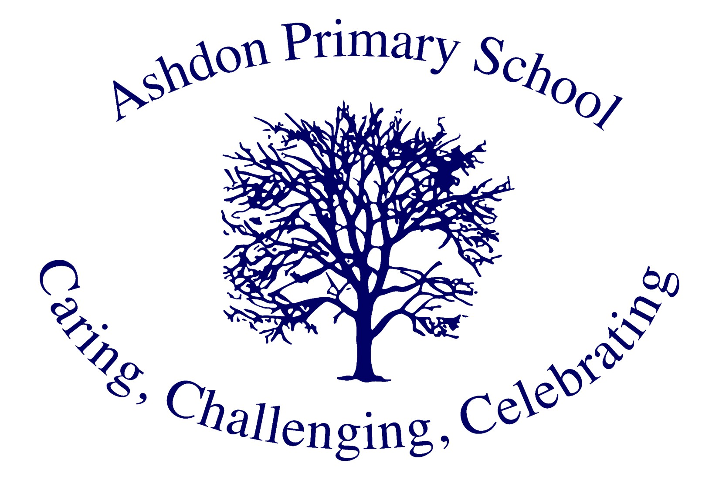
Ashdon Primary School

Early Years Foundation Stage Vision

Vision Update: December 2025
Vision Review: December 2026

At Ashdon Primary School, we are committed to providing every child with the very best start to their educational journey. Our EYFS provision in Mars Class embodies our core values of Challenge, Care and Celebrate, ensuring that our youngest learners develop a lifelong love of learning within a nurturing, stimulating environment.

Our Commitment to Every Child
We recognise that every child is unique, constantly learning and capable of being resilient, confident and self-assured. In our small school setting, we know each child exceptionally well, enabling us to tailor learning to individual starting points and needs. We are committed to ensuring that all children – including our SEND pupils and those eligible for pupil premium – receive the support and challenge they need to thrive.

Challenge: Building Strong Foundations Across All Seven Areas

The Prime Areas
We understand that the prime areas – Communication and Language, Physical Development, and Personal, Social and Emotional Development – form the essential foundations for all future learning and relationships. These areas are given the highest priority in our provision:
Communication and Language is at the heart of everything we do. Through rich conversations, story time, role play, and our weekend diaries, children develop the vocabulary and communication skills essential for success across all areas of learning. We use WellComm assessments to identify children who need additional support, ensuring targeted interventions are in place and their impact is tracked systematically.
Physical Development underpins all learning. As our PE Lead, Mrs Reynolds ensures children develop strong gross and fine motor skills through our Safari sessions (forest school activities), PE lessons, and carefully planned fine motor tasks. We understand that physical control is essential for early writing, and handwriting is systematically taught alongside our Monster Phonics programme.
Personal, Social and Emotional Development is deliberately fostered through My Happy Mind, supportive relationships with our key person, and daily opportunities to play and work cooperatively. Children learn to regulate their emotions, build resilience, form friendships, and develop a positive sense of self.

The Specific Areas
Building upon the prime areas, we challenge children through the specific areas – Literacy, Mathematics, Understanding the World, and Expressive Arts and Design:
Literacy development begins with our systematic Monster Phonics programme, taught daily from the Autumn term in Reception. Books are carefully matched to children's phonic knowledge, ensuring they can decode what they read. Handwriting is embedded throughout, with children making strong connections between sounds, letters and the physical act of writing. Our investment in Fred's Teaching for Reading strengthens both fluency and comprehension, building the foundations for the strong reading outcomes we achieve throughout the school.
Mathematics is taught through practical activities, manipulatives, and problem-solving, building deep understanding of numbers to 10. Children explore number bonds, patterns, and relationships, developing the fluency, reasoning and problem-solving skills that underpin our whole-school mathematics priorities.
Understanding the World is enriched through our Safari sessions, community partnerships with local churches, visits from the library bus, and hands-on experiences like hatching chicks in our classroom. These varied experiences broaden children's horizons and ignite curiosity about the world beyond Ashdon.
Expressive Arts and Design provides opportunities for creativity, self-expression, and imagination through a wide range of media, materials, music, role play, and storytelling.

Equal Prominence for All Areas
All seven areas of learning are given equal prominence in our provision. Our learning environment is carefully organised to ensure each area is visible, well-resourced, attractive, and regularly refreshed. This balanced curriculum ensures children develop the breadth of knowledge, skills and understanding needed for a successful transition to Year 1.

Care: How We Nurture Every Child

Our Teaching Approach
We embrace a balanced approach to teaching and learning that is appropriate for each child's age and stage:
- Child-initiated play – Children lead their own learning, exploring interests and developing independence, creativity and problem-solving
- Adult-guided learning – We observe carefully, responding to interests and guiding learning through skilled interactions, questioning and modelling
- Direct teaching – As children progress through Reception, we increasingly teach essential skills and knowledge explicitly, particularly in phonics, mathematics, and writing, preparing them for Year 1
We support the three characteristics of effective learning: playing and exploring, active learning, and creating and thinking critically. Through appropriate challenge, supportive relationships and celebration of effort, children learn to persist, regulate their emotions, manage behaviour, and treat others with kindness and respect.

Knowing Every Child
Our small school enables us to know every child exceptionally well. Each child has a key person who builds a warm, secure relationship with the child and their family, understands their individual interests, strengths and needs, and ensures the child feels safe, valued and confident to take on challenges.
Where children have additional needs – whether SEND, disadvantaged circumstances, speech and language delays, or other barriers to learning – we implement a clear graduated approach (Assess, Plan, Do, Review) to ensure their needs are met and they make excellent progress from their starting points.

Outstanding Learning Environments
Our exceptional school grounds and surrounding countryside provide outstanding learning environments for our youngest children. Our monthly Safari sessions connect children with nature, support physical development, and provide meaningful contexts for learning across all areas. Both our outdoor provision (mud kitchen, exploratory areas, physical development opportunities) and our carefully organised indoor classroom promote independence, encourage conversation, and provide access to high-quality resources.
Our environment is decluttered, inviting and purposeful. Displays reflect children's interests and learning, showing progression and celebrating achievements. Continuous provision is planned carefully to balance child-initiated and adult-led activities, and is regularly reviewed and refreshed to maintain engagement.

Partnership with Families
We recognise that parents and carers are children's first and most important educators. We build strong partnerships through:
- Weekend diaries that provide opportunities for children to share home experiences, strengthening the home-school link
- Regular communication through ClassDojo (weekly updates) keeping families engaged in their children's learning
- Stay and play sessions (Autumn and Summer terms) where parents see learning in action
- Home learning that supports school teaching, particularly in reading
- Clear communication about children's progress and any additional support needed

Assessment that Informs Teaching
Our ongoing formative assessment is integral to our teaching. We observe children daily, using our knowledge to shape learning experiences. We complete baseline assessments on entry to Reception, the progress check at age two for our youngest children, and the EYFSP at the end of Reception using the early learning goals.
Progress is tracked systematically across all seven areas of learning using our termly tracking spreadsheet. Assessment informs planning, ensuring every child makes excellent progress from their unique starting point. We focus our time on interacting with children rather than excessive paperwork.

Safeguarding and Wellbeing
Care means keeping children safe and promoting their wellbeing. Our rigorous safeguarding procedures, key person approach, paediatric first aid provision, nutritious food, safer eating practices, and health and safety measures ensure every child in Mars Class is protected, cared for and supported.

Celebrate: The Impact of Our EYFS Provision

Outstanding Outcomes
We are proud of our EYFS outcomes. In 2025, 86% of children achieved a Good Level of Development (GLD) – a remarkable improvement from 53% in 2023. This demonstrates the impact of our curriculum and the dedication of our staff. We are committed to maintaining or exceeding these excellent outcomes whilst ensuring every child makes strong progress from their starting point.

Achievement in the Prime Areas
By the end of EYFS, children leave as:
Confident communicators who listen attentively, hold conversations, express their ideas using full sentences, use rich vocabulary, and ask questions to extend their learning. Our focus on Communication and Language, supported by WellComm assessments and targeted interventions, ensures children have the language skills essential for future success.
Physically confident individuals who move energetically and competently, negotiate space safely, demonstrate strength, balance and coordination, hold a pencil effectively using the tripod grip, and understand the importance of physical activity and healthy choices.
Resilient, respectful learners who understand their own feelings and those of others, regulate their behaviour appropriately, persevere when facing challenges, work and play cooperatively, form positive relationships, and demonstrate independence in self-care.

Achievement in the Specific Areas
By the end of EYFS, children leave as:
Readers and writers who read words and simple sentences using their phonic knowledge, demonstrate understanding of stories, write recognisable letters, spell words by identifying sounds, and write simple sentences. Our systematic Monster Phonics programme and Fred's Teaching for Reading ensure strong foundations for the excellent reading outcomes achieved throughout our school (80% at Year 6 SATs 2024). Children who fall behind are identified quickly through our tracking systems and receive targeted phonics interventions to close gaps rapidly.
Mathematical thinkers who have deep understanding of numbers to 10, automatically recall number bonds, count beyond 20, compare quantities confidently, and explore patterns. These strong foundations support our whole-school focus on mathematical reasoning and problem-solving.
Curious explorers with knowledge of their environment, the natural world, past and present, and different communities. Our Safari sessions, community partnerships, and rich experiences have broadened their horizons and ignited their curiosity.
Creative individuals who use materials and tools confidently, share their creations, role-play narratives, and sing with enjoyment.

Readiness for Year 1
Our EYFS provision ensures children are fully prepared for the next stage of their education. They have:
- Secure foundations in phonics, early reading, and writing
- Deep understanding of early mathematics
- Strong communication and language skills
- Physical confidence and control
- Independence and self-regulation
- Positive attitudes to learning
- The resilience and characteristics of effective learning needed for Year 1

Seamless Progression
We have worked as a whole staff team to carefully align our EYFS framework with our Key Stage 1 curriculum, ensuring continuity in learning and consistent high expectations as children transition from Mars Class. Year 1 teachers receive comprehensive information about each child's development, and the foundations built in EYFS enable children to thrive throughout their time at Ashdon and beyond.

Progress for All
We celebrate that every child makes excellent progress from their unique starting points:
- SEND children receive personalised support through our graduated approach, making meaningful progress
- Pupil premium children benefit from targeted support and enrichment opportunities, achieving well
- Children with speech and language delays receive WellComm interventions that close gaps
- All children, regardless of background or ability, leave EYFS as confident, capable learners

Celebrating Success
We celebrate children's achievements in multiple ways:
- Friday celebration assemblies where children share their learning
- Stars of the Week and Pawsome Reader of the Week awards (reading to our school dog)
- House points and ClassDojo points
- Displays showcasing children's work across all areas
- Regular communication with families about progress
- Stay and play sessions where families see learning in action
- Annual events including performances and our music festival

Our Curriculum Drivers in Action
Everything we teach in EYFS is shaped by our four key drivers:
Exposure, Opportunities and Aspirations – Through Safari sessions, library bus visits, community events, and diverse learning experiences, we broaden children's horizons and help them understand they can pursue any dream.
Reading and Oracy – Our focus on Communication and Language, systematic phonics, Fred's Teaching for Reading, daily story time, and rich conversations ensure children develop strong foundations that support our excellent whole-school reading outcomes.
Physical Development – Our PE Lead's expertise, forest school experiences, and systematic handwriting instruction ensure children have the physical confidence and control essential for writing and confident movement.
Resilience and Respect – Through My Happy Mind, appropriate challenge, supportive relationships, and consistent celebration of effort, children develop the characteristics of effective learning and the resilience needed to face challenges throughout their education.

Looking Forward
We are committed to continuous improvement and have clear priorities for 2025-26:
- Maintaining our excellent GLD outcomes (86%+)
- Strengthening weaker areas (handwriting, literacy, maths) through focused support
- Ensuring our learning environment is consistently well-organised, inviting and purposeful
- Using ClassDojo weekly to engage parents in children's learning
- Tracking the impact of WellComm interventions systematically
- Maintaining our focus on Communication and Language as the highest priority
- Ensuring all seven areas of learning continue to have equal prominence
- Supporting our mixed Reception/Year 1 class effectively, ensuring both curriculums are delivered well

At Ashdon Primary School, our Early Years Foundation Stage is where the journey begins – where children are challenged with an ambitious curriculum that builds strong foundations across all seven areas of learning, cared for as individuals through warm relationships, responsive teaching, and inclusive practices that meet every child's needs, and where every achievement is celebrated as children develop into confident, capable learners ready for Year 1 and beyond.
Through our commitment to the EYFS statutory framework, our unique school values, and our relentless focus on ensuring excellent outcomes for every child, we provide the secure, stimulating foundation that enables every child to flourish.

Published: December 2025
Review: December 2026

