
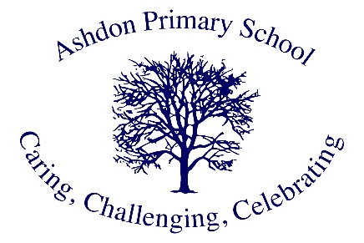

Ashdon Primary School
Philosophy 4 Children Policy

Vision Statement
At Ashdon Primary School, Philosophy for Children (P4C) provides pupils with a unique space to develop their speaking, listening, and thinking skills. Through our philosophy assemblies, we teach oracy—the ability to communicate effectively using spoken language.

Core Communication Skills
Through P4C, we develop students' abilities to:
- Express themselves effectively and confidently
- Speak eloquently and articulate ideas clearly
- Influence through verbal communication while listening and responding to others
- Develop and utilize appropriate vocabulary
- Structure thoughts coherently for others' understanding

Philosophy and Curriculum Integration
Approaching the National Curriculum philosophically means exploring beyond surface-level facts to examine questions and concepts that engage pupils and teachers alike. Philosophy harnesses imagination and reasoning to explore fundamental concepts such as justice, truth, knowledge, and beauty. Within our philosophical community of enquiry, adults and pupils collectively search for meaning. Students become reasonable in dual aspects—developing strong reasoning abilities while remaining receptive to others' perspectives.
As Socrates (470-399 BCE) stated, "The unexamined life is not worth living."

Implementation Strategy
Assembly Structure
- Classes develop and select their own philosophically rich questions aligned with termly topics
- Discussions emphasize full, considered sentences and respectful listening
- Student-driven subject matter enables speakers to be authorities on their chosen topics
- Peer and teacher attention builds student confidence
- Extended discussions enhance articulation and critical thinking skills
Benefits for All Learners
- SEND and disadvantaged pupils particularly benefit from opportunities for extended discourse
- Students experience reasoned debate and cordial disagreement
- Sessions begin with thought-provoking stimuli connected to curriculum or relevant issues
- Group readings of books and stories serve as discussion catalysts
- Vocabulary expansion through concept exploration (e.g., 'justice', 'equality', 'immortality')

Impact Assessment
Academic Achievement
- Students demonstrate high academic progress in reading, writing, and mathematics
- P4C develops:
  - Articulation of ideas
  - Logical thinking through abstract concepts
  - Enhanced oracy skills
  - Strengthened mathematical reasoning
Evidence-Based Results
According to the Education Endowment Fund's efficacy trial, P4C shows particular effectiveness in improving mathematics, reading, and writing performance among pupils receiving free school meals.

