

Ashdon Primary School
2026 Spring Menu - Week 2

W/C - 2nd March / 16th March
 | Monday | Tuesday | Wednesday | Thursday | Friday
Main Meal | Pizza with Cheese and Tomato Topping | Beef Burgers in a Brioche Bun | Pork Sausages | Cheesy Pasta Bake | Battered Chicken Chucks
Vegetarian  option | Cheddar Cheese Panini | Cheddar Cheese in a Brioche Bun | Vegan Sausages | Tomato Pasta Bake | Quorn Dippers
On the side | Selection of Fresh Salad | Selection of fresh Salad | Mashed Potato and Baked Beans | Garlic Bread | Chips  Sweetcorn
Dessert | Fresh Fruit | Cornflake Clusters | Fruit Jelly | Fruit Cocktail and Cream | Ice Cream Tubs

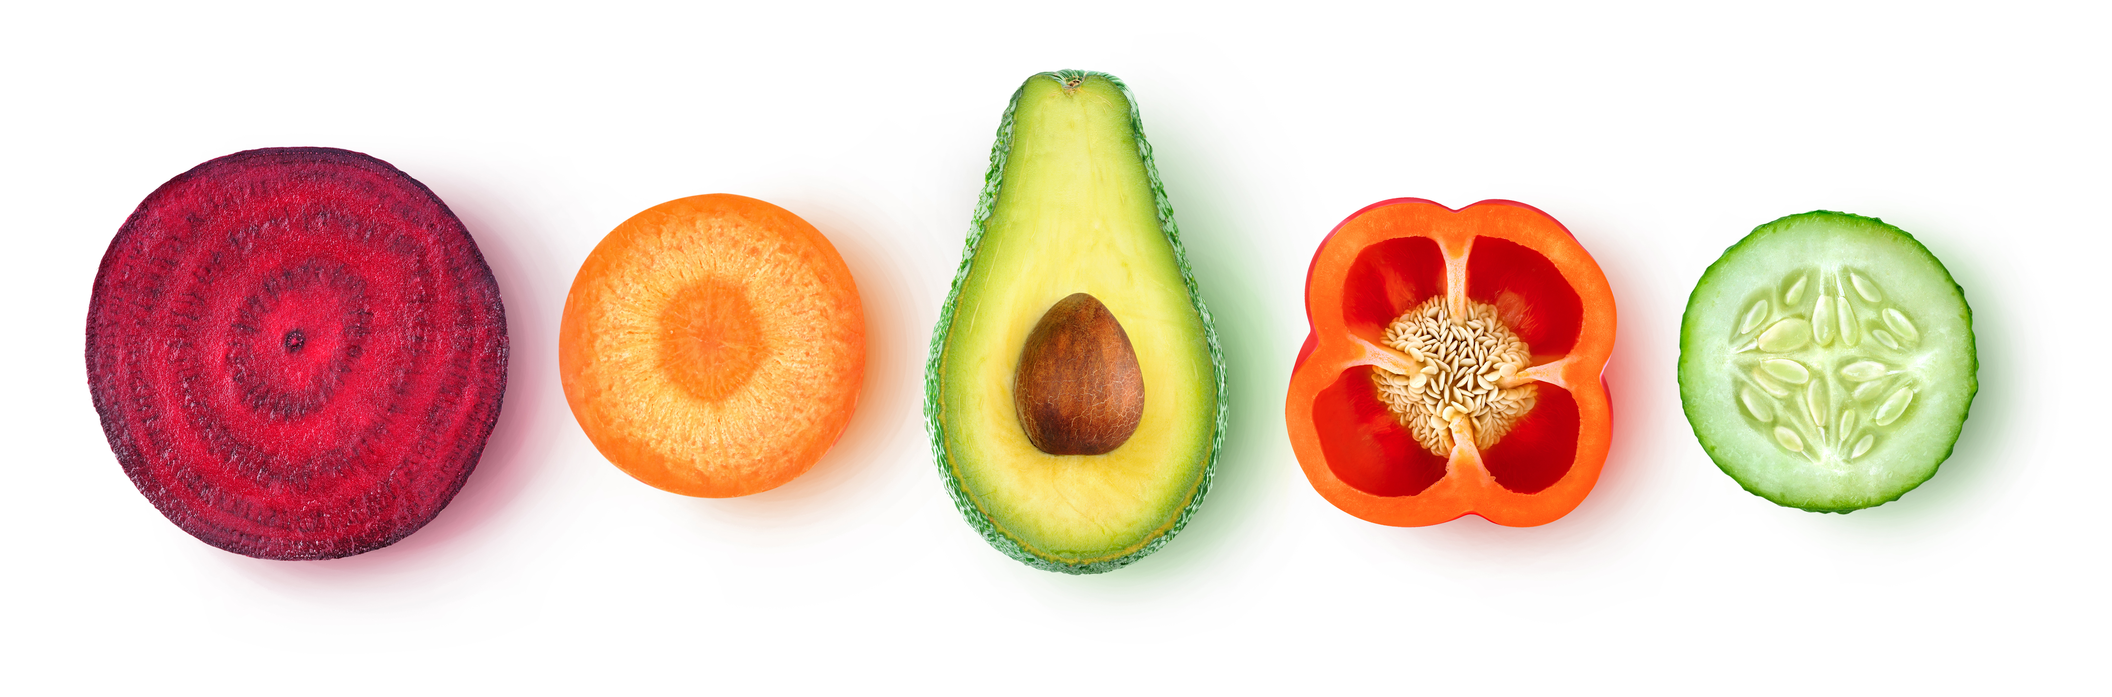
There are fresh fruit and yogurts available daily.

