

Ashdon Primary School
2026 Autumn Menu - Week 2

W/C – 7th Sep / 21st Sep /5th Oct /19th Oct / 9th Nov / 23rd Nov / 7th Dec
 | Monday | Tuesday | Wednesday | Thursday | Friday
Main Meal | 100% British Beef Burgers | Chicken chunks with (optional) Sweet & Sour Sauce | Pork Sausages | Sweet Tomato & basil pasta | Fish Fingers
Vegetarian  option | Cheddar Cheese Brioche Rolls | Quorn Nuggets | Quorn Sausages | Pesto Pasta | Vegetarian Fingers
On the side | Salad Bar | White Rice & Corn | Hash Browns & Baked Beans | Optional Cheese on top | Chips & Peas
Dessert | Fresh Fruit | Cornflake Clusters | Caramel Mousse | Fruit Cocktail & Cream | Icy Cream Pots

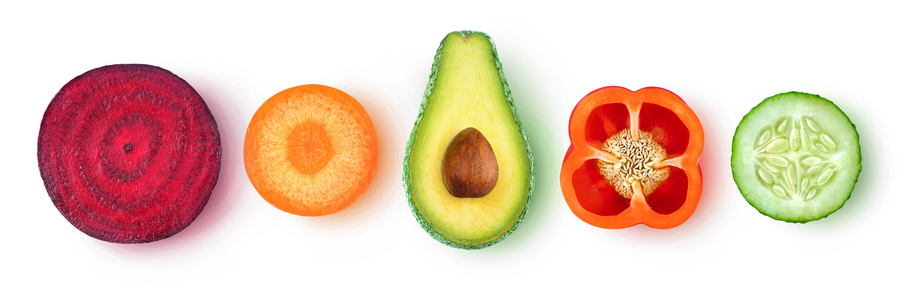
Fresh fruit and yogurts available daily

