
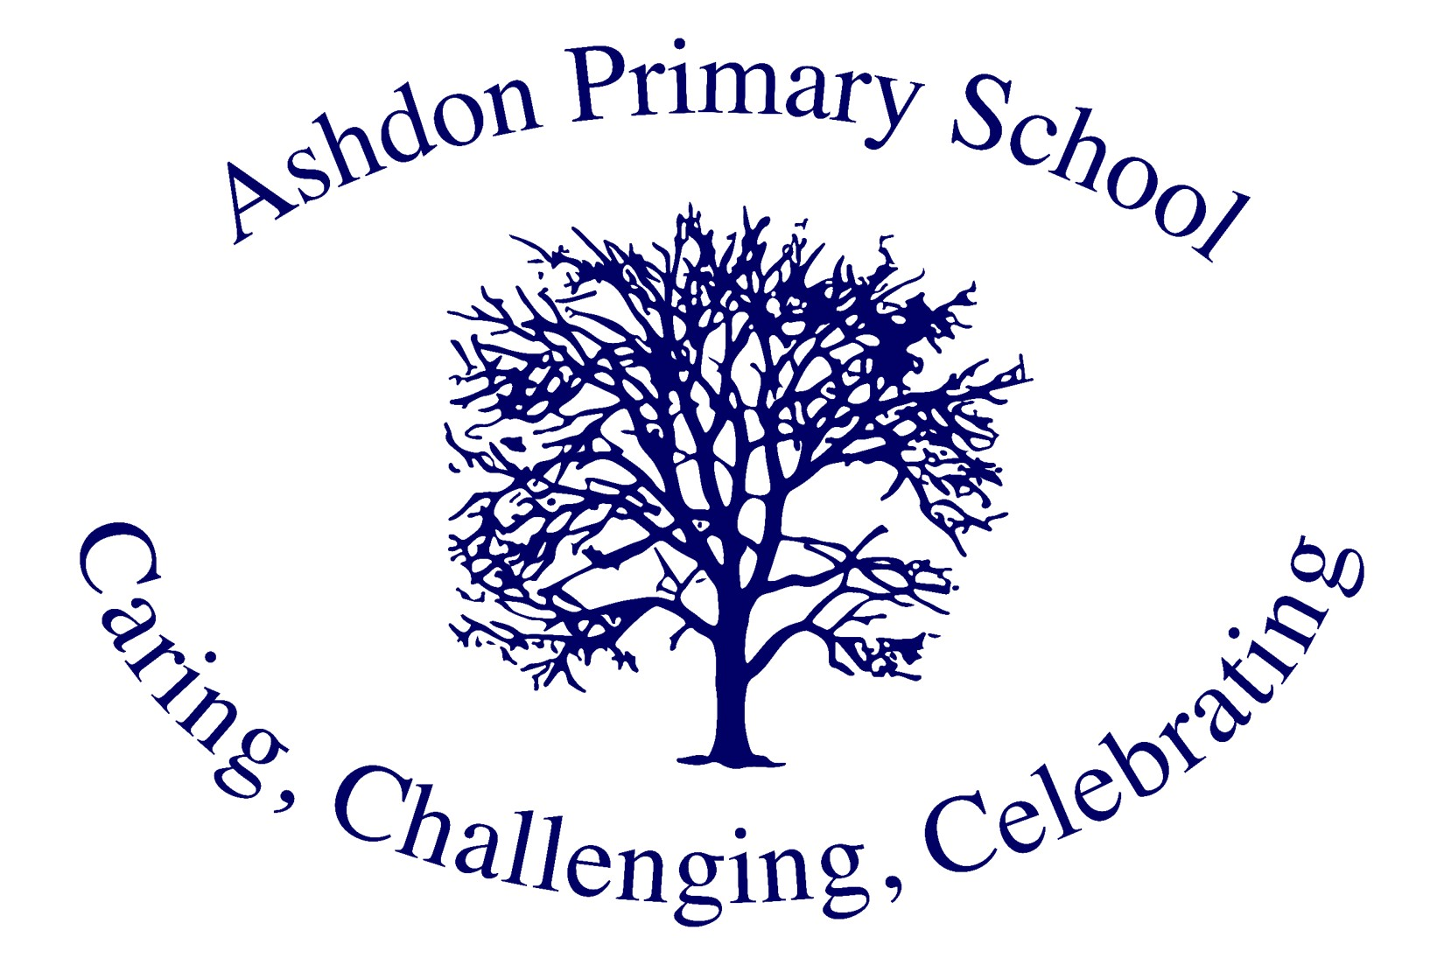
Ashdon Primary School

Whole School Curriculum Vision

Vision Update: December 2025
Vision Review: December 2026

Our Context
Ashdon Primary School is a small, maintained village school serving children aged 4-11 (Reception to Year 6). With currently 58 pupils organised into four mixed-age classes (R/Y1, Y2, Y3/4, Y5/6), we are a close-knit learning community where every child is known, valued, and supported to thrive. Our rural village setting and strong links with our local Methodist and Anglican churches enrich our curriculum and foster a deep sense of community and belonging.
As a small school, we embrace both the opportunities and challenges of mixed-age teaching. Our dedicated team of 6 teachers, 1 HLTA, 4 teaching assistants, and specialist teachers in PE and music work collaboratively to ensure every child receives a rich, broad, and ambitious curriculum. With 19% of our pupils identified as SEND (including 2 with EHCPs), inclusion is at the heart of everything we do.

Our Vision
At Ashdon Primary School, our curriculum vision is rooted in our core values: Challenge, Care, and Celebrate. These three principles guide what we teach, how we teach it, and what our pupils achieve.
We believe that every child, regardless of their starting point or additional needs, deserves an education that develops them as confident, curious, and compassionate learners. Our curriculum is purposefully constructed to provide clear progression from the Early Years through to Year 6, equipping pupils with the knowledge, skills, and values they need to embrace the opportunities and challenges of their next stage in life.
Our vision is for Ashdon pupils to:
- Develop deep knowledge and understanding across all subjects, building systematically from secure foundations
- Become well-rounded individuals who understand how to live safe, healthy, and happy lives
- Develop cultural capital, resilience, and character that enables them to thrive both academically and personally
- Acquire a genuine love of learning and reading that extends beyond the classroom
- Understand their role as responsible citizens with knowledge of British values, respectful relationships, and their place in the wider community

Our Values in Action
CHALLENGE - What we teach at Ashdon
Our curriculum aims to enable pupils to:
- Develop as confident, curious learners who value education, make effective progress across all subjects, and achieve their full potential regardless of their starting points or additional needs.
- Build deep knowledge and understanding through a carefully sequenced curriculum that develops from EYFS through to Year 6, embracing the opportunities and challenges of our mixed-age class structure.
- Become well-rounded individuals who understand how to live safe, healthy, and happy lives, whilst developing the cultural capital, resilience, and skills needed to thrive in their next stage of education and beyond.
- Experience a rich, broad, and balanced curriculum that values every subject as a discipline in its own right, from core subjects to specialist teaching in music and PE, and encompasses British values, wellbeing, and community engagement.
- Develop a genuine love of learning and reading through exposure to quality texts, expert teaching, and enrichment opportunities that extend beyond the classroom and into our rural village community.

CARE - How we teach at Ashdon
The Ashdon Primary School staff use the curriculum and our values to enable pupils to learn through:
Purposeful planning and sequencing: Learning is carefully planned to build upon prior learning and develop deeper understanding from EYFS to Year 6, with particular attention to ensuring progression within our mixed-age classes (R/Y1, Y2, Y3/4, and Y5/6).
Clear progression frameworks: Subject-specific progression documents, based on the National Curriculum, account for how our curriculum is both spiral and interleaved. These documents map prior knowledge, key objectives, essential vocabulary, and key themes, ensuring both knowledge acquisition and skill development.
Cognitive science-informed practice: We focus on both the journey our curriculum takes children on and the application of cognitive psychology principles to build up knowledge and skills systematically, with opportunities for retrieval, spacing, and interleaving.
Consistent teaching approaches: A dialogic approach where teachers 'Think Out Loud' is embedded across the curriculum, ensuring pupils can engage deeply with their learning, articulate their thinking, and develop metacognitive skills.
Specialist teaching: Professional PE and music teachers deliver high-quality instruction, with all pupils receiving expert PE teaching weekly and progressive music tuition (ukulele, recorder, glockenspiel, and music theory).
Tailored support: With 19% of our pupils identified as SEND (including 2 with EHCPs), our curriculum is delivered through Quality First Teaching alongside targeted support from our dedicated team of 6 teachers, 1 HLTA, and 4 TAs.
Flexible grouping: English and mathematics are taught to Y2, 3, and 4 together in the mornings, allowing for focused teaching whilst maintaining age-appropriate expectations and challenge.
Wellbeing at the heart: The My Happy Mind programme and our RSHE/PSHE curriculum ensure that emotional literacy and wellbeing are explicitly taught and modelled throughout school life.

CELEBRATE - What the pupils have learnt
Our curriculum ensures that pupils:
- Achieve ambitious standards in reading, writing, and mathematics that ready them for their next stage of education, with progress carefully tracked and celebrated across our small school community.
- Develop as confident readers with a genuine love of reading, having been exposed to quality texts across the curriculum and received systematic phonics teaching and guided reading support.
- Acquire deep subject knowledge through a broad, balanced, and well-structured curriculum with clearly sequenced learning that ensures progression in each subject, respecting the integrity of each discipline.
- Build strong foundations through our mixed-age class structure, which allows younger pupils to learn from older peers whilst ensuring each year group meets age-appropriate expectations.
- Demonstrate wellbeing and pride in all that they achieve, supported by our whole-school focus on mental health, resilience, and the My Happy Mind programme.
- Develop cultural capital through a broad range of enrichment opportunities, specialist teaching, community links, church partnerships, and experiences that extend their understanding beyond our rural village setting.
- Apply their learning across subjects, making connections between different areas of the curriculum and demonstrating understanding through dialogue, written work, and practical application.
- Understand how to be safe, healthy, and happy with knowledge of British values, respectful relationships, and their role as responsible members of their school and wider community.

Our Curriculum Structure
The curriculum at Ashdon Primary School is purposefully constructed to provide a clear progression model linked to expectations set out in the National Curriculum. In the Early Years (Reception) we follow the statutory guidance of the EYFS framework. For Years 1–6 we follow the National Curriculum.
As a small village school with mixed-age classes, we operate a two-year curriculum cycle (Year A and Year B) to ensure all pupils receive full curriculum coverage whilst benefiting from our close-knit learning community. Subjects are taught in topics and/or units that are carefully planned and sequenced to enable the development of knowledge and skills alongside gaining understanding of key themes and ideas. Vocabulary acquisition is a key element of this approach.
Each subject is valued as its own discipline with clear progression, and where appropriate, meaningful cross-curricular links are made to deepen understanding and help pupils make connections in their learning.
We teach the following subjects: English (phonics, reading, comprehension, writing, spelling, punctuation, grammar, and oracy); mathematics; science; computing; French (KS2); humanities/topic (geography and history); PE; RSHE/PSHE (including My Happy Mind – wellbeing); RE; music; art; D&T; British values; and P4C (Philosophy for Children).

Our Curriculum Priorities 2025-2026
Our School Development Plan identifies clear priorities that drive curriculum improvement and ensure all pupils make strong progress:
- Writing Development - Strengthening writing across the whole school from early oracy and phonics through to confident, accurate writing across genres
- Mathematics Development - Building reasoning and problem-solving skills alongside fluency
- Reading Development - Developing fluency and comprehension through systematic phonics and quality texts
- Assessment and Tracking - Using data strategically to identify gaps and ensure effective interventions
- Inclusion - Supporting all vulnerable pupils and removing barriers to learning
- Personal Development and Wellbeing - Developing well-rounded, resilient individuals through PSHE, British values, and enrichment
- Attendance and Behaviour - Maintaining high standards and supporting all families
- Leadership and Governance - Ensuring strategic leadership drives continuous improvement
- Safeguarding - Keeping children safe and ensuring they feel safe
- Early Years - Providing excellent EYFS provision with high GLD outcomes

Our Commitment
At Ashdon Primary School, we are committed to providing an education that:
- Challenges every child to reach their full potential through an ambitious, well-sequenced curriculum
- Cares for every child as an individual, ensuring tailored support, wellbeing, and inclusion for all
- Celebrates every achievement, fostering pride, confidence, and a lifelong love of learning
Through our carefully constructed curriculum, expert teaching, and our core values of Challenge, Care, and Celebrate, we prepare our pupils not only for their next stage of education but for life as confident, compassionate, and capable citizens.

