

Ashdon Primary School
2026 Spring Menu - Week 1

W/C - 23rd February / 9th March / 23rd March
 | Monday | Tuesday | Wednesday | Thursday | Friday
Main Meal | Jacket Potato with a choice of fillings Tuna Mayonnaise | Pasta with Beef Meatballs in a Tomato Sauce | Roast Chicken Dinner | Pork Sausage Rolls | Fish Finger Sticks
Vegetarian  option | Cheese  Beans | Vegetarian Balls in a Tomato Sauce | Roast Quorn Dinner | Cheese and Pesto Pinwheels | Vegetable Finger Sticks
On the side | Selection of Fresh Salad | Selection of Fresh Salad | Roast Potatoes  Seasonal Vegetables Gravy and Stuffing Balls | New Potatoes Corn on the Cob | Crispy Chips  Peas
Dessert | Fresh Fruit | Cooks choice of Cake | Fruit Crumble and Custard | Peaches and Cream | Ice Cream Pots

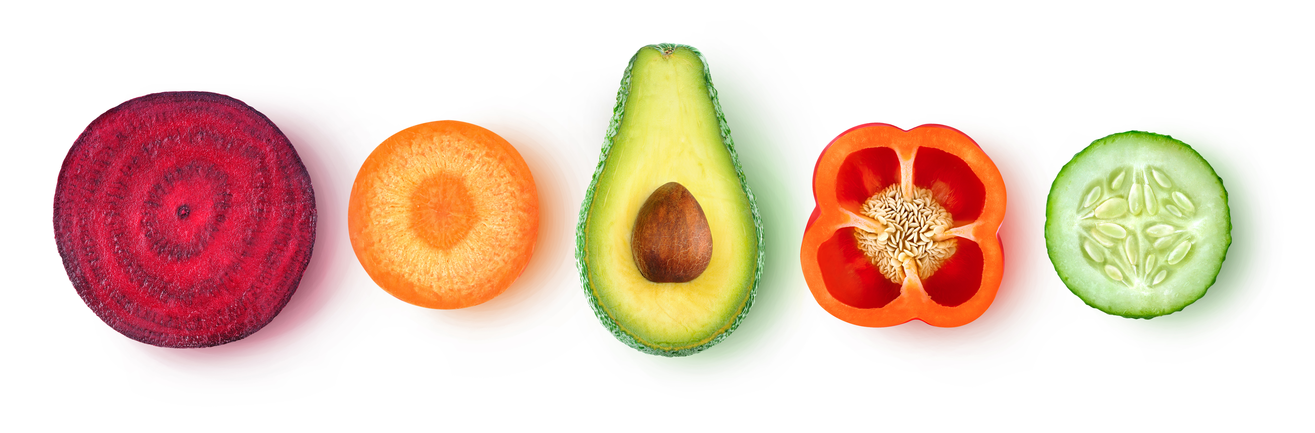
There are fresh fruit and yogurts available daily

